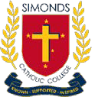 | Newsletter  Issue 5: 30 May 2019
St Mary’s 7-9 Campus 273 Victoria St, West Melbourne 3003 Tel: 9321 9200 FAX: 9321 9299
St Brigid’s 10- 12 Campus 20 York St, Fitzroy North 3068 Tel: 9403 6800 FAX: 9403 6899 www.sccmelb.catholic.edu.au principal@sccmelb.catholic.edu.au
FROM THE PRINCIPAL – Mr Peter Riordan

Last Monday, Simonds Catholic College undertook its cyclical Victorian Registration and Qualifications Authority (VRQA) Review. The purpose of the Review was to ensure that as a school we are meeting the Minimum Standards and Requirements for School Registration, and all other Commonwealth Requirements, including Child-Safe Standards. I am pleased to report that our VRQA Review was successful, and it really is an important process, as the College policies and processes are scrutinised to ensure they reach the required standard.
Prayer of Service

Lord, we thank you for calling us to be your Church.
Through our Baptism we are called to service and to witness.
In the Eucharist we sustain and strengthen that call.
By serving others we follow your example and proclaim our beliefs.
By our Christian generosity we demonstrate our love and care.
Lord, help us always to worship you, as you deserve,
To grow faith and service and to give without counting the cost.
We ask this trough Chris our Lord.
Amen

In the coming week students in Years 7-12 will begin their Examinations for a number of subjects studied in Semester One, whilst all students studying a VCE Unit 3/4 subject will sit the General Achievement Test (GAT)on Wednesday 12 June. Arrangements for students in the coming Examination period are included in this newsletter. I wish all students well in the coming week, and hope that exam results will be a reflection of the hard work and effort that students have put into their studies during first semester.
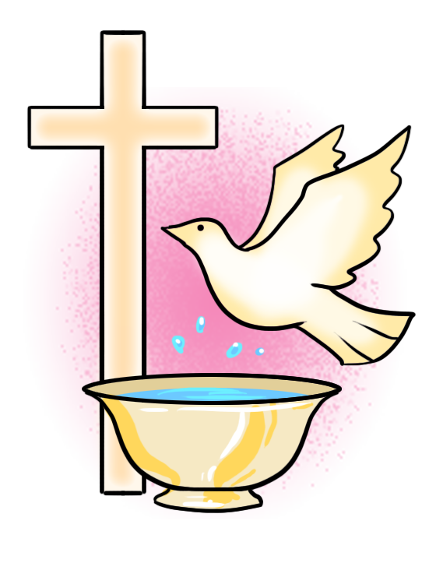

I will be taking Long Service Leave from 6/6/2019 until the beginning of Term 3 – 15/7/2019. During my absence Ms Helen Koutoulogenis and Mr. Robert Anastasio will be Acting Co-Principals, where they will assume all duties and responsibilities for the Principal. I thank them for their preparedness to take on this role during my absence, and I am sure they will receive full support from our College community during this time.

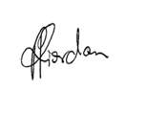
Yours sincerely
Simonds Catholic College supports the inclusion, safety and wellbeing of all students.
Mr Peter Riordan
Principal | Simonds Catholic College

W@SP (Wellbeing @ Simonds Program) News
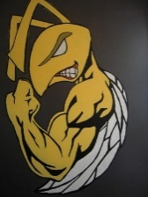

In each newsletter for the remainder of the year, one member of the senior wellbeing team will provide a piece on a mental health issues relevant to teenagers. This week’s offering is from Hayden Bright, year 10.
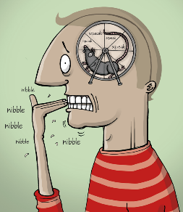
- Anxiety

One in fourteen young Australians (6.9%) aged 4-17 experience an anxiety disorder (www.youthbeyondblue.com).
From my point of view I think that teenagers suffer anxiety in increasing numbers because of school stressors. Those stressors are work load, SACS and exams, homework, thinking that in the future "I have to have a good job", the thoughts that "I may be disappointing my parents".
Non-school stressors include part-time work resulting in less time for schoolwork.
Social media can be enjoyable AND stressful. It can become stressful because there is the need to constantly contribute and check and to keep on top of what everyone's doing. Generally, most of the posts are not really about anything significant, but the need to check and comment or like is there. The stress of worrying about what people think and say about you (appearance, smarts, money) is always there.
Having to chose between something you love doing like keeping fit and spending time on schoolwork, can be stressful - you love the sport but you need to spend time on schoolwork (which you don't love) - so you have to chose between something you really enjoy and something you just HAVE to do.
Sane advice to give on stress is "find the balance between doing what you love … and what you have to do … and have one or two really good mates who don't talk crap behind your back and to whom you can talk about being stressed (and they with you too) … so you feel supported and not alone."
This “young men’s health” site is excellent. Take a look …
https://youngmenshealthsite.org/guides/anxiety/

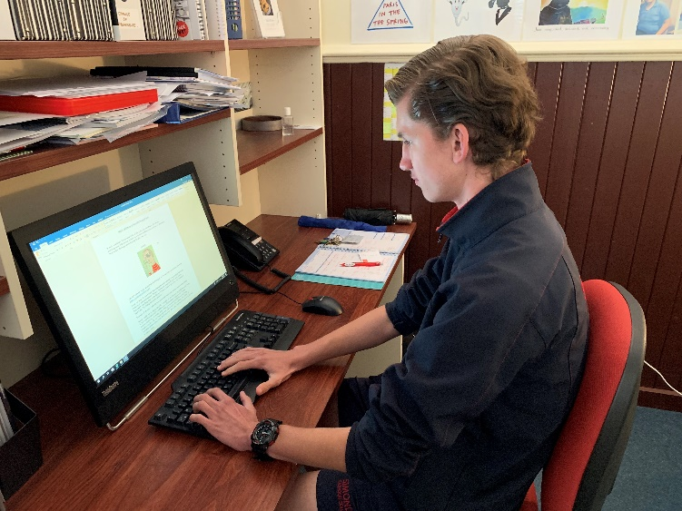
Hayden Bright, Year 10, SWT.

- Male Suicide in Australia
Beyond Blue has just released sad and alarming figures relating to male suicide: “between June 2015 and July 2016 there were 30,197 ambulance attendances for men who had attempted suicide or had suicidal thoughts”. Of course, this figure does not take into account those males who have suffered silently with suicidal ideation … and attempts that have been unreported – and so, the figure is higher. We can increase protective factors, keeping suicidal thoughts at bay, by creating strong, genuine family connection; by keeping communication open – even when it’s difficult; by being absolutely honest; by encouraging the many genuine, productive male activities and behaviours that some have come to regard as “too dangerous,” “too risky,” “too loud’” etc; by encouraging and rewarding effort; by supporting one doing one’s best (as distinct from competing); by having an open view of maleness and manhood (as distinct from pigeonholing expected attitudes and behaviours) and by regarding maleness as good (as too often, maleness is regarded as “bad” … a view propped up by the relative few who do wrong ).

For more info and assistance go to: www.beyondblue.org.au

Simonds Catholic College supports the inclusion, safety and wellbeing of all students.
- Healthy Eating

Too often we hear of obesity rates amongst young people in Australia and too often we see young people (and older) eating food that is of poor quality – high in fats, sugar and salt.
The student wellbeing team under the leadership of Mahmud Hamed conducted a healthy food challenge so that members of the college community could post what good foods they were eating – giving a short commentary on why that food was considered healthy. It was good to hear the amount of discussion boys had whilst looking at the pictures of the staff and student participants. The winners of the challenge, Adamo Deodato, Mr. Di Fabrizio and Ms. Pradel were partaking of good foods such as wholemeal bread, avocado, tomato, carrots, beans, broccoli, lettuce, cucumber, extra virgin olive oil, chickpeas, pecorino cheese, nuts, seeds, oats, raspberries, kiwi fruit, and almond milk. We all need to look after our bodies and fuel our bodies with good quality food so as to get the very best out of them.
Thanks to all participants and to our foodie-judge, Ms. Nugara.

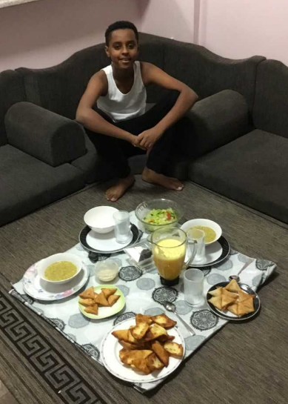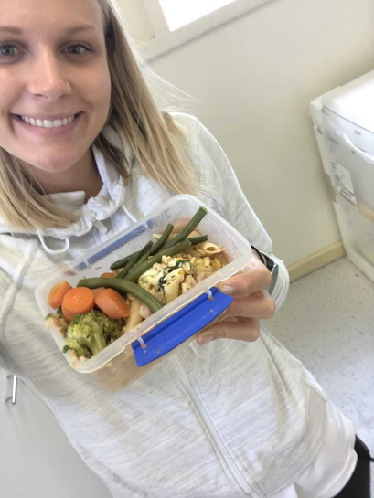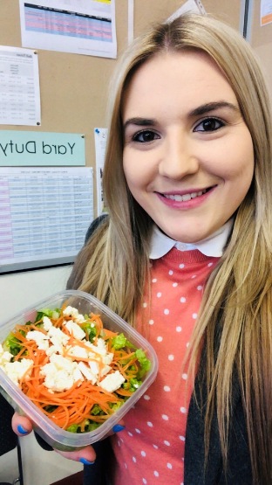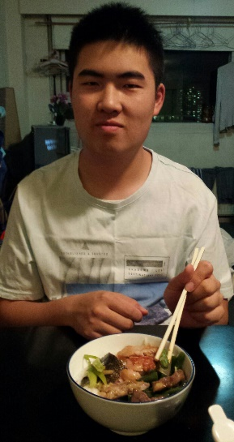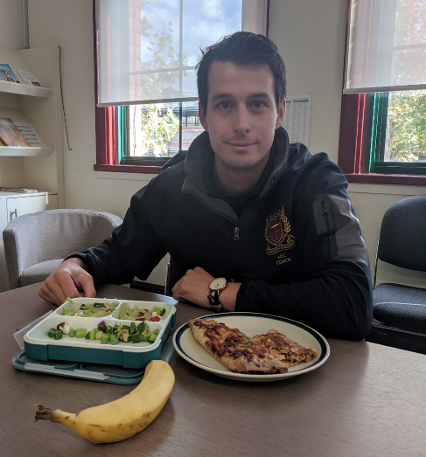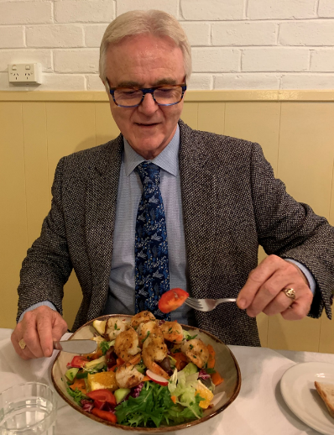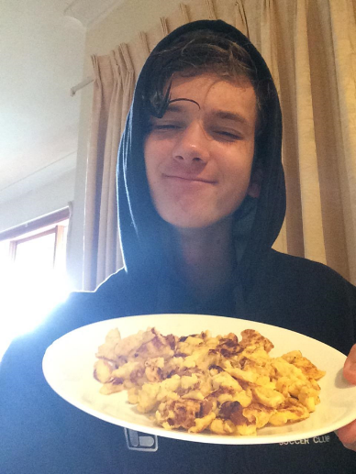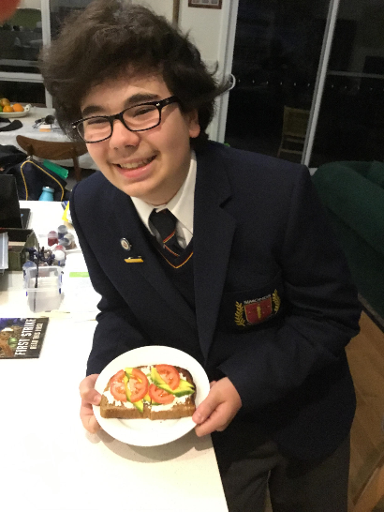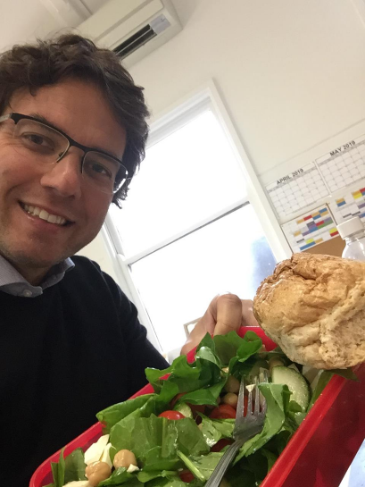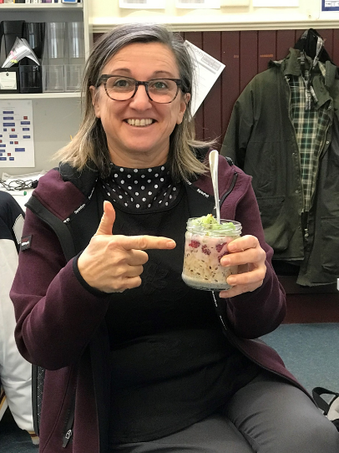
Winners: Adamo Deodato Mr Di Fabrizio Ms Pradel

All the best –
Mr. P Rohan | Co-ordinator of Student Wellbeing / Counsellor

Simonds Catholic College supports the inclusion, safety and wellbeing of all students.

Japan Tour

On 3 April, 15 boys flew to Japan, accompanied by Ms Yao, and Mrs Koutoulogenis and Ms Sinis. After a brief stopover in Singapore airport we arrived in Hiroshima Airport and headed to the Hiroshima International Plaza to settle in and have a buffet dinner. Then we relaxed in our yukatas, which are a lighter summer version of kimonos.

The next day we went to Wood Egg, a factory famous for making okonomiyaki sauce. After learning about the history of okonomiyaki, we toured the factory production line and made some okonomiyaki. Later that evening, we met our homestay hosts. Our homestay was for 2 nights, and despite the language barrier we all had a great time experiencing Japanese culture and home life with our temporary families.

At the end of our homestay visits, we regrouped and spent the day touring Hiroshima together. We visited the Hiroshima Peace Memorial Park and Museum, and a guide explained what happened when the atomic bomb was dropped on Hiroshima. We also visited the Pokemon Centre and Loft Department Store and had some free time in the heart of Hiroshima. Three of us decided to go shopping one last time in Hiroshima and ended up missing out on the group dinner, so we got creative and sorted ourselves out, buying lots of different things from the shops. It was a great dinner - check out the photo!

The next day, we visited Miyajima Island by ferry. We visited Itsukushima Temple, where the temple gate stands at the edge of the sea, and took lots of photos. We had nice views of the gate, because it was a sunny day. After our bento lunches we explored the streets and stalls of Miyajima before meeting up again for a Momiji Monju making workshop.

After dinner, we had a calligraphy lesson. It was the last activity we did before we left Hiroshima and we each chose one kanji to frame and keep.

The next morning, we headed to Kyoto. We arrived at Kyoto Station, the second biggest station building in Japan, and we made our way to our accommodation located nearby. We were put into groups of 3 per room. Ms Yao gave us 1,000 yen each for lunch at Sukiya, a popular restaurant chain. After lunch we headed to Higashiyama, a beautiful part of Kyoto with some amazing scenery. We had some free time there before moving on to Gion Corner to watch a 7 Traditional Performances show in one hour. It was nice but some of us were so exhausted we fell asleep during the show. Afterwards, we made our way through the beautiful streets of Kyoto until we finally arrived at our restaurant for Shabu Shabu.

The next morning we were delayed due to some of us waking up late with upset stomachs, but we eventually headed out to Fushimi Inari Taisha Shrine. Our second stop was a place called Nishijin, to do some weaving and eat our bento lunches. We then made our way to the most beautiful place in Kyoto, the Philosopher’s Walk, which is a path along the river lined with cherry blossom trees. We had free time to explore on our own afterwards, before meeting up again for dinner.

After dinner, we did some more local sightseeing. We saw the Kyoto Tower and some stairs that have LED lights on them turn on in a specific pattern to show a picture from the Kyoto station building. Even though it was a rainy day, we still managed to enjoy ourselves and fit a lot in.

Our last day in Kyoto was just as busy. In the morning, we visited Tōdai-ji temple in Nara, which was massive and full of free-roaming deer. According to Japanese Shinto religion, deer are considered to be messengers of the gods. We went inside the temple, which had 3 big Buddha figures. Inside the temple there was a pillar with a hole in the bottom, and people believe if you can fit through the hole you will have good luck.

After lunch at Nara Park, we returned to Kyoto for some free time in the Kyoto district. Dinner was a sushi train restaurant, which was a great experience.

We started the next day our final shinkansen trip. After 3 hours, we were finally in Tokyo, Japan’s beautiful, and modern capital and our last big city for this trip. After we dropped off our luggage at our accommodation, we headed to Tokyo’s most famous district for technology and otaku culture, Akihabara.

Akihabara was vibrant, modern and very crowded, a real change of pace from Melbourne’s city vibe. We spent the whole afternoon looking around, shopping and eating until meeting up again for a hamburger and chips dinner, which was pretty good. When we got back to our accommodation, some of us went to the onsen (public bath house) and some of us went to bed. Day 1 of Tokyo was complete, and we were all extremely tired, but happy.

The next morning we had an early buffet breakfast, so we could have more time to spend during the day. Our first stop was Yokohama, which is Japan’s docklands. We noticed all the ships docking at the port and the big Ferris Wheel that shone its lights upon the city. We then visited a museum in Yokohama dedicated to cup noodles. We got to make our own cup noodles, which was a great experience and very enjoyable. Our final product was also enjoyable and delicious! Next, we visited the Yokohama toy museum, then headed to Yokohama’s Chinatown district for a yum cha style dinner. After Yokohama, we caught a train to the famous Shibuya crossing. We spent a bit of time in Shibuya before we headed back to our accommodation to rest. Day 2 was loads of fun.

The next day we visited the Museum of Natural Disasters, where we got to experience simulated natural disasters. We ate lunch at Hotto Motto and were quite satisfied with their chicken-karaage. Then we headed to a robot museum in Odaiba to see some amazing robots such as Asimo. After that, we walked to the Toyota Museum, which wasn’t far away, and got to see the new Toyota cars.

We started our final day in Japan rushing through breakfast before heading to Disneyland. We spent the whole day there, and it was fun, with many fun rides, things to buy, and sights to see. We tried out all the rides and some of the special food they were selling and bought some souvenirs to remind us of the great time we were having. Overall, it was a good day in Disneyland. We are all also happy to be home, but still thinking about how good our trip was and how many great memories we made.

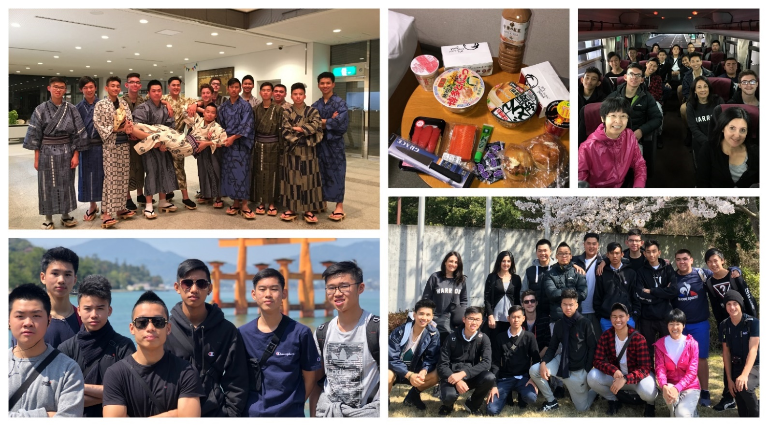
Year 11 | Nick Tu

Simonds Catholic College supports the inclusion, safety and wellbeing of all students.

St Mary’s Semester One 2019 Examinations | Year 7-9

Exams will be held from Tuesday 11 June to Thursday 13 June. Students are required to be in full school uniform.
Semester One Examination Timetable
YEAR | Period/Date | Monday  10 June | Tuesday  11 June | Wednesday  12 June | Thursday  13 June | Friday  14 June
9 | 1 & 2 | Queen’s Birthday Public Holiday  NO CLASSES | English | Maths | HPE | Report Writing & Correction Day  NO CLASSES
9 | 3 & 4 | Queen’s Birthday Public Holiday  NO CLASSES | Science | Italian /Japanese | Humanities | Report Writing & Correction Day  NO CLASSES
8 | 5 & 6 | Queen’s Birthday Public Holiday  NO CLASSES | English | Maths | Normal School Day for Year 7&8 students | Report Writing & Correction Day  NO CLASSES
7 | 5 & 6 | Queen’s Birthday Public Holiday  NO CLASSES | Maths | English | Normal School Day for Year 7&8 students | Report Writing & Correction Day  NO CLASSES

Arrangements for Year 7 & 8
Normal classes will run for students in Year 7 and 8 throughout the exam period, apart from when they have their exams on Tuesday and Wednesday afternoon. Students are required to be at school for the full day, each day. Please note, Wednesday 12 June is NOT a shortened day. Students will be dismissed at 3.05pm.
Arrangements for Year 9
Exams will be held over three days. Students will be dismissed once their final exam for the day has been completed. Community Service will NOT run on 13 June.
Study Guides
All students are encouraged to prepare thoroughly for the exams. They should follow advice provided by subject teachers and seek further assistance as required. A Study Guide to assist with the preparation for the exams has been provided to each Year 7-10 student – this may be downloaded from the news section on iSimonds. Links to the Study Guides are on iSimonds. Parents can access these via PAM.

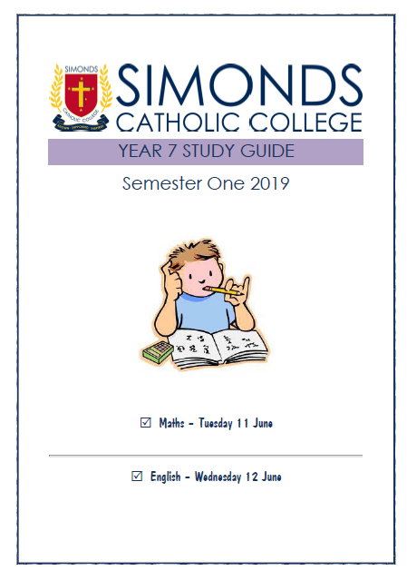 | 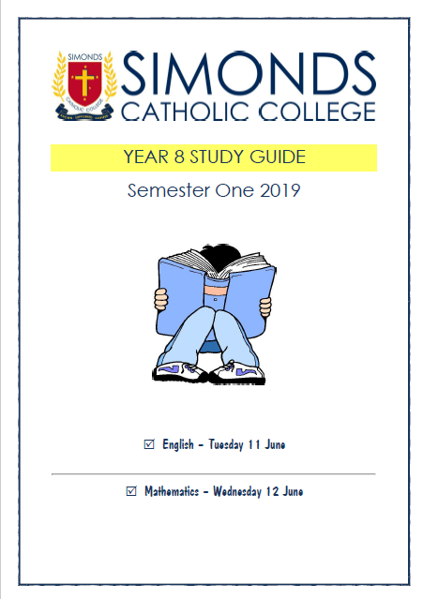 | 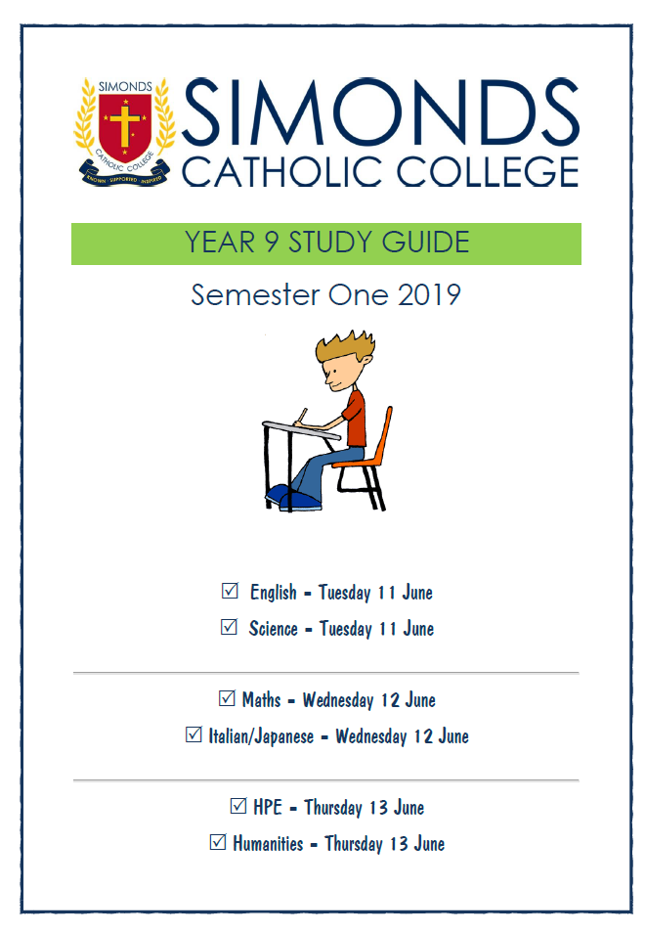 | 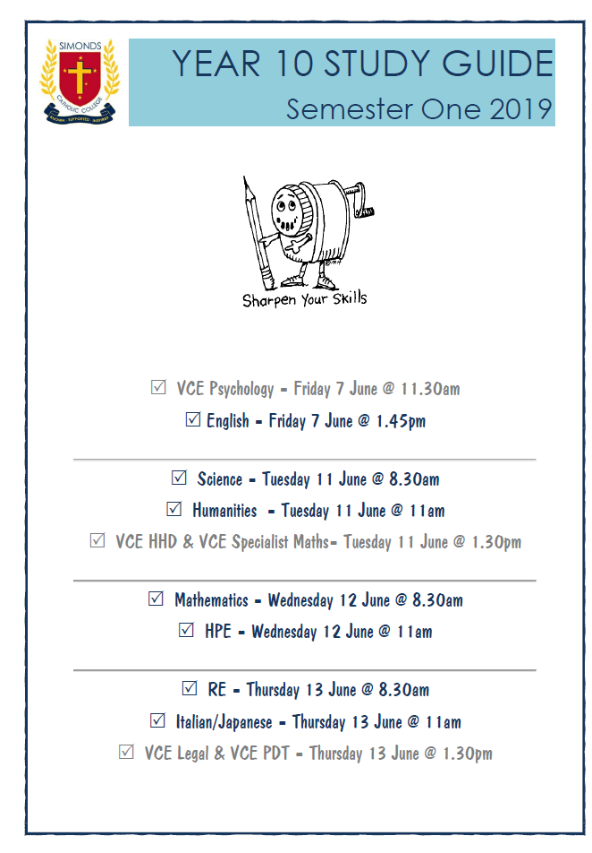
REMINDERS
- Wednesday 12 June will not be a shortened day. Year 7 & 8 students dismissed at 3.05pm.
- There will be NO CLASSES on Friday 14 June.

If your son is too unwell to attend school on the day of an examination, please contact his Year Level Coordinator. A doctor’s certificate should be provided to the school.

Mrs. H Koutoulogenis - Deputy Principal (Learning & Teaching) | Head of St Mary’s Campus

Kokoda Memorial Trail 1000 Steps | Year 8 Excursion

The Year 8 Simonds students had the privilege of attending the 1000 Steps Kokoda Memorial track on Wednesday May 15. It was a great day that involved learning a little bit about Australia’s history in World War 2, forming bonds when tackling a physical task and pushing through when things might get tough.
Two activities were undertaken during the day. One was an Anzac service run by the Dandenong Ranges National Park education officer Julia Pickwick. Our speakers: Massimo Iannuzzi, Jake Cesario, Kristian Cavallo, Trent Bright, Jayden Tan, Yousif Aboras, Christian Tringali, Jayson Chung and our flag raisers Nhial Michael and Zac Assouni represented our school well by helping in the service. A big thank you to our wreath layers also that were asked to help with short notice. The service ran well with everyone showing full attention and contributing to the anthem. Once that was done, the students undertook a task of answering a set of questions provided to them that allowed them to scan through the plaques at the memorial and learn about the different battalions that fought at the Kokoda Trail in Papua New Guinea.
The second activity for the day was a long walk up the 1000 steps trail that allowed them to get a small taste of what it might have been like for the soldiers trekking through the Kokoda trail and how tiring it might be for them if it was a lot hotter and they had to carry heavy packs with them. It was a great day for all and a good learning experience.
Mr. O Miet | Year 8 Co-ordinator

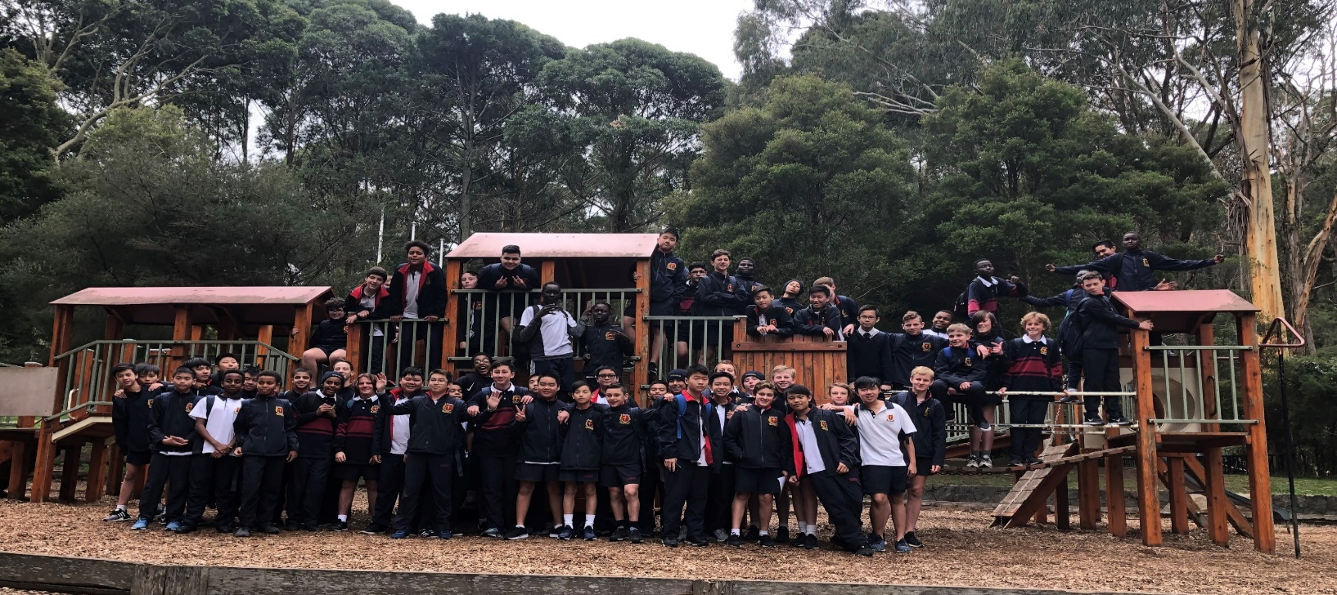

The Annual Brain Bee Challenge

Congratulations to all those who participated in Round 1 of the International Brain Bee Challenge. I am very excited to announce that we have 6 students in 2019 make their way through to Round 2, where they will be battling it out in the Victorian State Final at Melbourne University. The boys are listed in order of achievement. Good luck to those students!
- Eldrick Nuique
- Minh Anh Vo
- Elvin Tran
- Noah Seiderman
- Kevin Truong
- Michael Tesfay
Ms L Fisher | Head of Science

Simonds Catholic College supports the inclusion, safety and wellbeing of all students.






Support for

School
Leavers

Giving young people the best chance of making
a positive transition to life after

school

Information for Schools

Why
is

The Smith Family doing
this?

Schools already do
excellent work guiding
students’ decision making about careers and
pathways.

We
want to
support
the work you
already do to

give

young people the best
chance of
compl
eting

Year 12 or equivalent,
or
m
aking

a positive transition to life after
school, according to their needs and abilities.

What is it?

.

An initiative to support Learning for Life students in year 9-12 that are showing signs of disengaging with school, to make and action the best career decision for themselves at the time.

How does it work?
We work with schools to identify young people “at risk” of leaving school early. Drawing on our pre-existing relationship with those young people and their families, and using the skills of The Smith Family Career Coach, we build a picture of the young person’s strengths, passions and barriers and put in place a plan to move forward
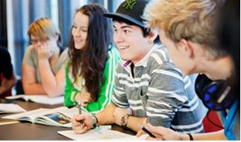

thesmithfamily.com.au
This will usually involve connecting them with existing programs, support networks or corporate supporters of the Smith Family. For more information, contact The Smith Family Partnership Coordinator, Darren Hughes, Family Partnerships Coordinator – 0412 285 302
Helping young Australians in need to
build better futures through education.

Simonds Catholic College supports the inclusion, safety and wellbeing of all students.

