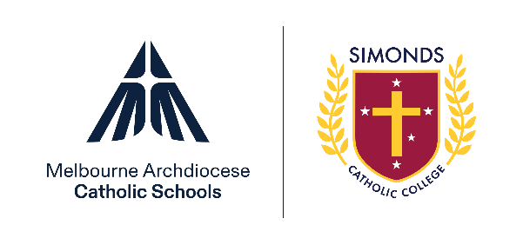

Democratic Principles Statement


Introduction
MACS schools operate with the consent of the Catholic Archbishop of Melbourne and are owned, operated and governed by Melbourne Archdiocese Catholic Schools Ltd (MACS).

Democratic Principles
MACS schools recognise that the school plays a vital role in advancing democratic ideals and principles. For democracy to continue to thrive, children must be taught democratic ideals and principles and to value its way of life. MACS schools will explicitly and implicitly support and promote the principles of Australian democracy, including a commitment to:
- elected government
- the rule of law
- equal rights for all before the law
- freedom of religion
- freedom of speech and association
- the values of openness and tolerance.
MACS schools will prepare children and students to become citizens who will preserve and shape democracy in the future through their curricular and extracurricular programs. Democratic values will be taught explicitly in the curriculum and implicitly through the child’s experience of the school, in educational programs, and from what is taught, and how it is taught.

Reporting and monitoring
The MACS board will monitor the publication of this Democratic Principles Statement by MACS schools through the Annual Report to the School Community (ARSC) Principal Attestation and regular school compliance review processes (at least once every five years).

